Example on how to create an ePortfolio for the CSD cooperative group
- Go to the CSD ePortfolio page:
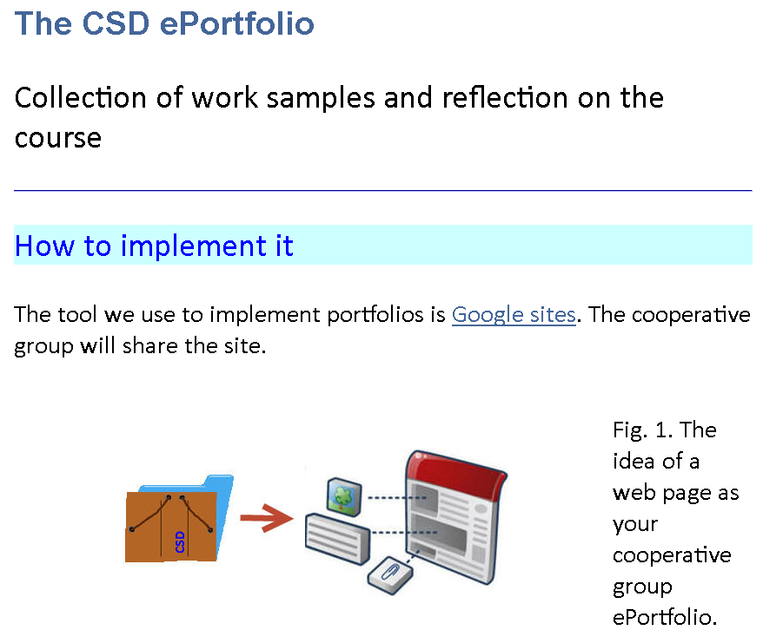
- Click on Google Sites, log in, and create a new web:
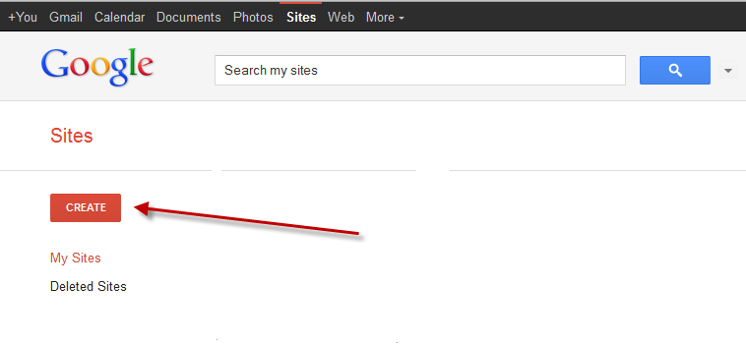
- Let’s find the suitable template for the web:
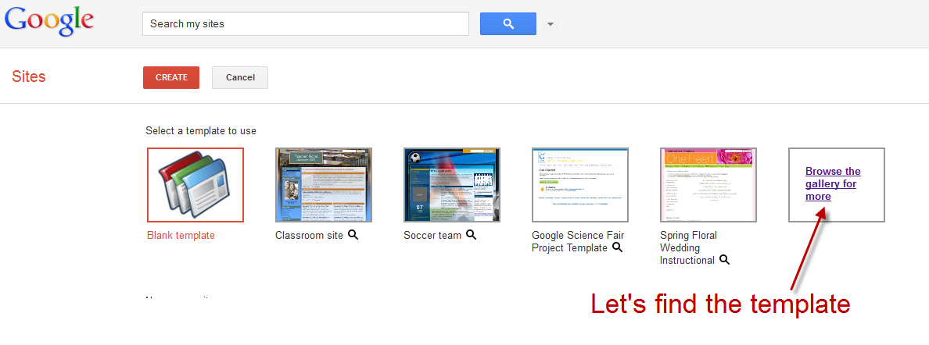
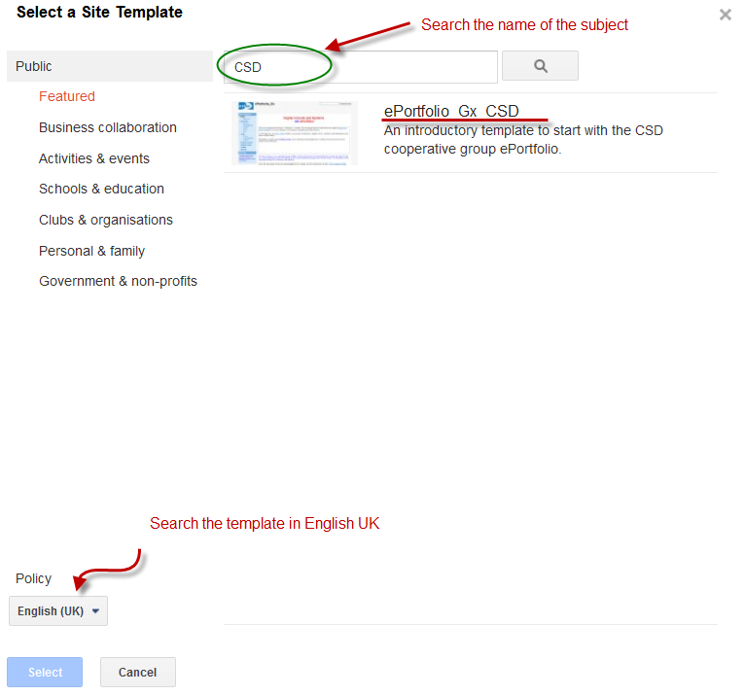
- Input the web site name and create the web with the right template: eportfolio_Gx_CSD
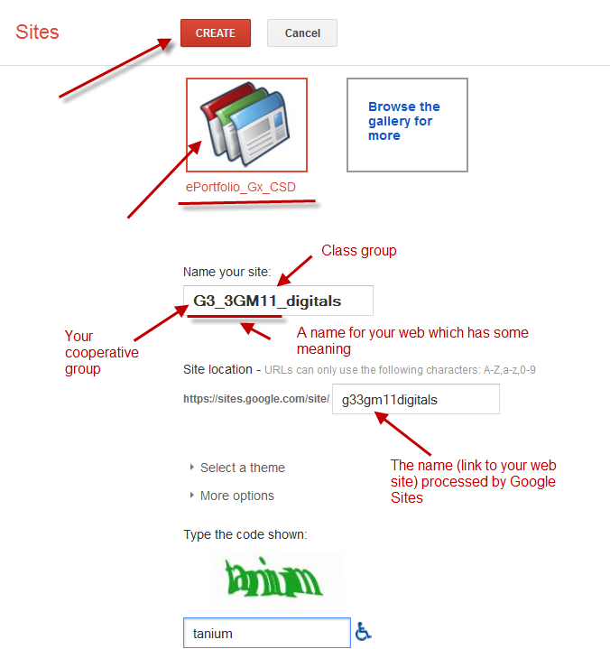

- Start editing the home page to remove, add and customise the information
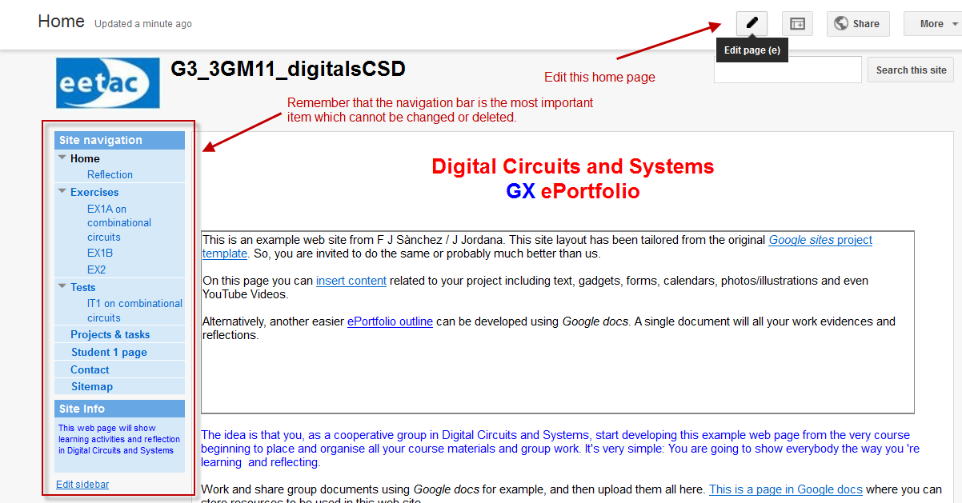
Instructors will go straight through the navigation web to find your exercises.
- Now, go and edit the EX1A page:
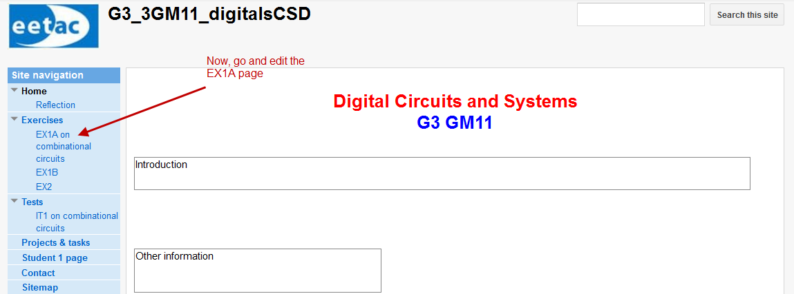

- Delete the sample example links and files:
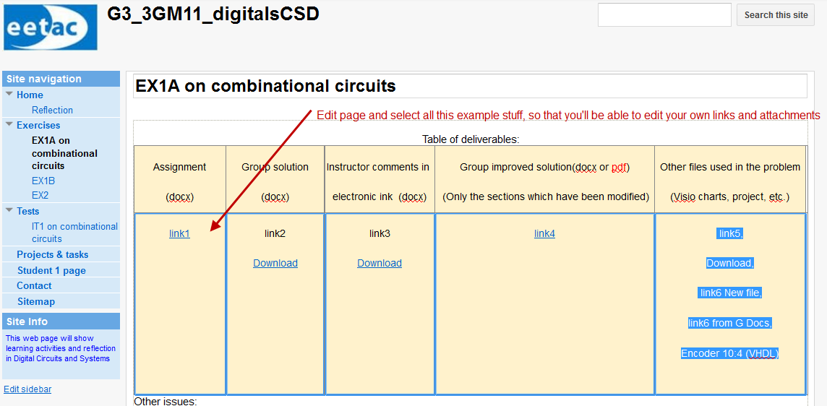
- Remove the sample attachments:
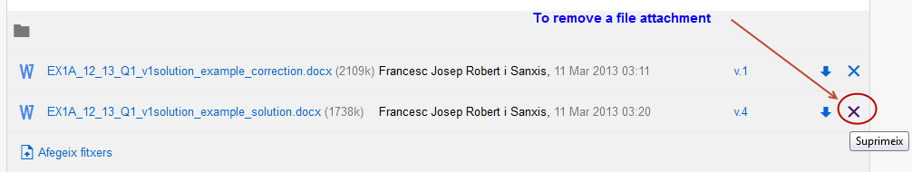

- Add a link to the EX1A assignment. Go the term web page and right click to the docx file to copy its address.
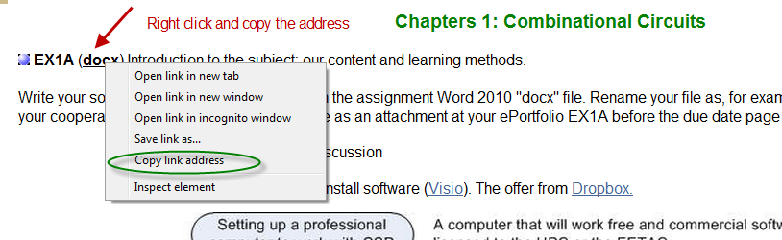

- Paste it on the left column on the table
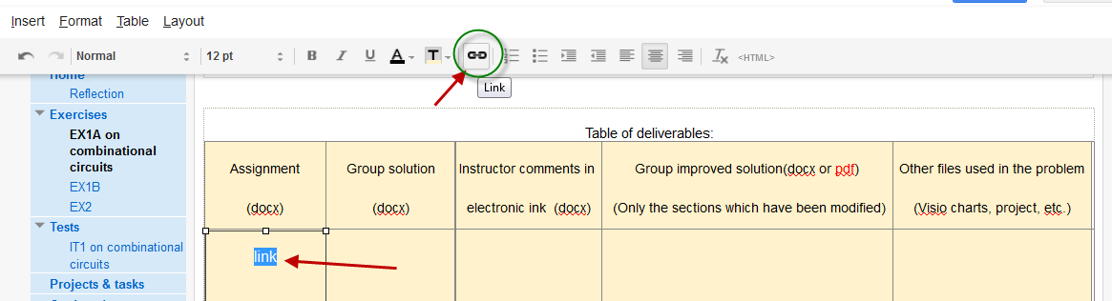
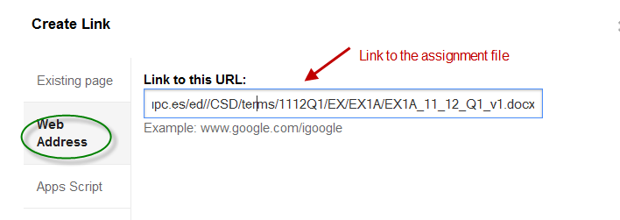
- Attach for example, your solution docx file once finished, and make a link on the table in the second column:
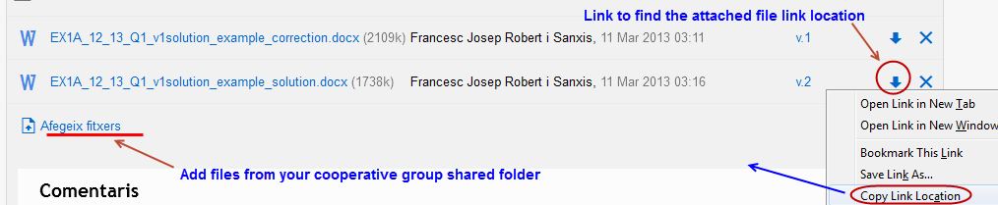
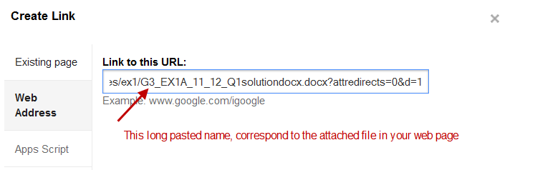
- And finally, add other files related to the problem here at this fifth column:
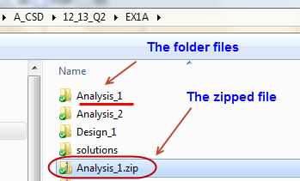
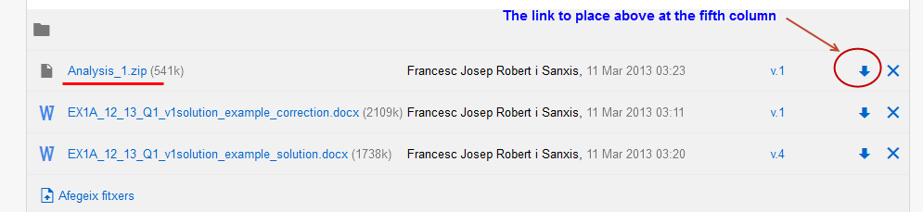
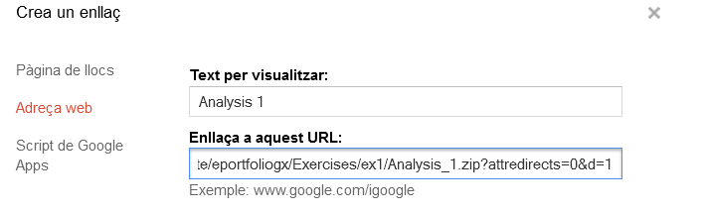
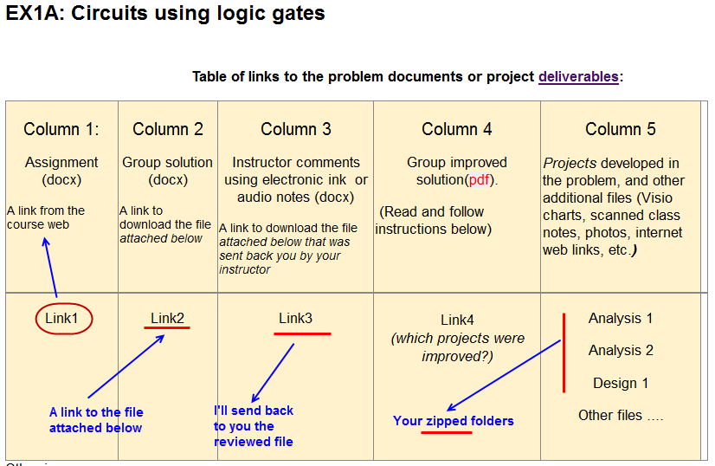

In this way, you as a group have started a web portfolio to work for the whole semester. The web has to be public, and the owners which edit permissions have to be only the cooperative group members.

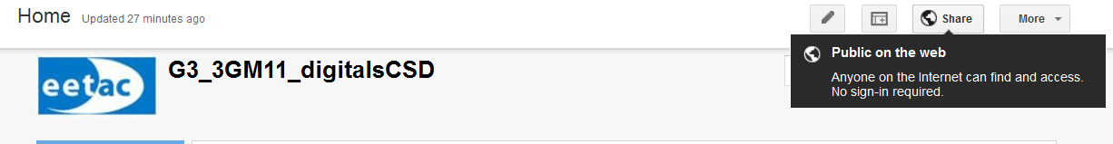
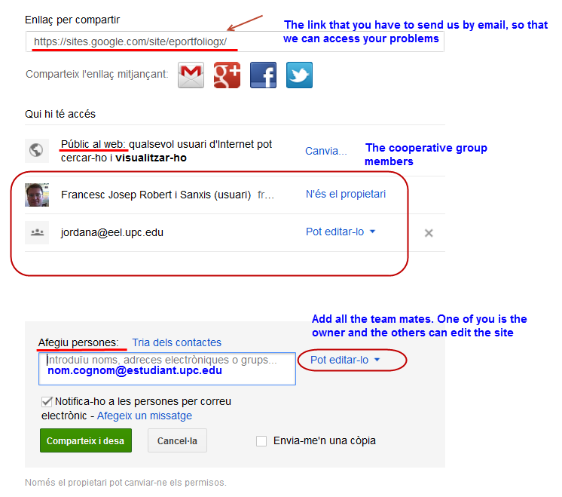

And finally, is something goes wrong … and you need to start again …. Just go to manage site tab and:
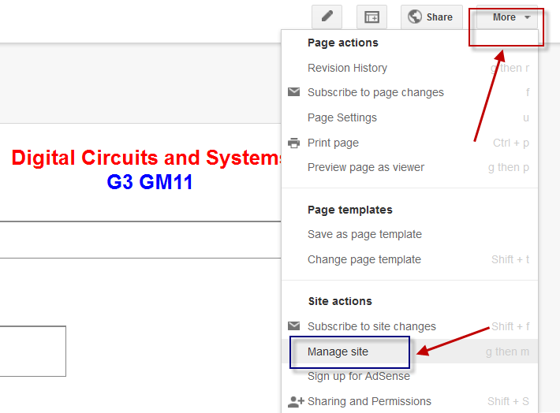

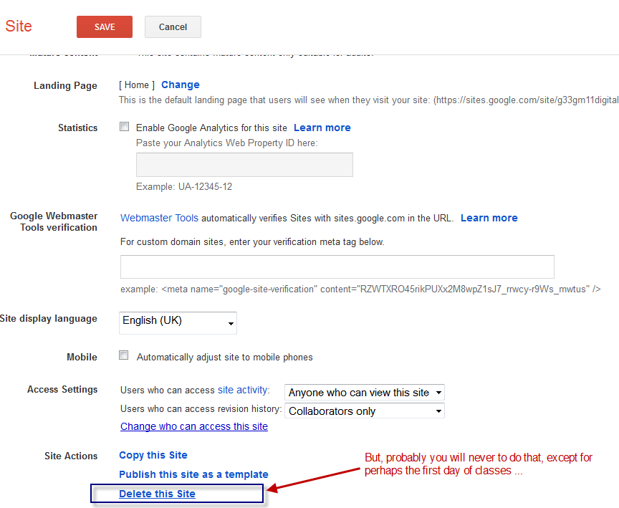
Indeed, we hope that you may use this tool not only for this semester, but for other subjects as well. Remember the many advantages that may have for you to have such a suitable tool to show the entire world how you are learning this engineering stuff. Review other links related to the ePortfolio and the way it can serve on educational purposes.
- Our ePorfolio Web page
- Books on the ePortfolio

